*Site Notes*

Here I present some general comments about the sampling sites to provide context for our population genomic work. We located *Rhinanthus minor* populations across elevational transects in southern Alberta and BC. I first focus on our focal transects in the Kananaskis Valley, AB (Fig. 1, Table 1) where, as part of another study on the phenology of *R. minor*, we established three elevational transects of four study sites for a total of 12 sites. Each of the focal transects ranged from valley bottom (~1450 masl) to above the treeline (> 2200 masl); sites were located on more or less east facing slopes at ~1450 masl (low), ~1750 masl (mid-low), ~1950 masl (mid-high), and 2200-2340 masl (high). Focal sites were arranged with the goal of maintaining geographic distance between transects and elevation classes within transects, to minimize the confound of distance alone on gene flow parameters. However, this was not possible at higher elevations, and since elevation is the primary predictor variable, we prioritized elevation –and therefore environmental distance– before geographic distance between sites.

../Dropbox/DaveEnsing/Proposal/Proposal_Figures/updated/Site_Map.pdf

**Fig. 1.** Rhinanthus minor study sites in the Kananaskis Valley, Alberta. Note that distance is slightly distorted in this figure due to the three dimensional image; the scale bar is thus approximate.

Of particular interest for my thesis is the nature of and potential for geneflow among populations as many of the genetic hypotheses for range limits surround the positive and negative effects of incoming genotypes and alleles, particularly in edge populations. Despite being regularly visited by bumblebees (*Bombus* spp.), *Rhinanthus* readily self-fertilises, and pollen movement is likely to be of secondary importance for geneflow. Seed movement (via endo- or exozoochory), however, could be an important source of genetic variation in edge populations. On one hand the introduction of novel genotypes by seed movement may have limited impact on the viability of edge populations and may simply generate sink populations, as seed are carried from more range central populations to the edge. Alternatively, such movement could occur among edge and interior populations and due to some non-zero gene exchange due to pollination, contribute novel genetic variation to edge populations.

In terms of seed movement, it is apparent that the low sites on each transect are valley bottom sites (Fig. 1), and that we might expect higher levels of geneflow among these sites, simply because it is easy for seed dispersers (ungulates via endo / exozoochory) to travel between these sites. Indeed, elk and deer are regularly seen at these sites, and animal highways run along the valley bottom and the Kananaskis river.

In contrast, we might expect Kidd to be more isolated from the two Nakiska transects because it is separated from them by Ribbon Creek, which forms a deep valley between Mt. Kidd on the left and Centennial Ridge / Mt. Allan in the upper right of Fig. 1. Furthermore, elk herds were regularly seen grazing, travelling and rutting on the Nakiska ski hill (upper right, Fig. 1), potentially connecting sites on and around the ski hill, including NkS-MH, NkS-H, NkN-MH and NkN-H. Further support for this idea comes from our access to NkS-MH. We travelled along an animal highway from the ski hill road to this site and encountered scat from elk (most common), deer, moose, bighorn sheep and bear along the trail. Thus the potential for seed movement among sites on Nakiska appears to be high.

Similarly, I also suspect that the Nakiska North High site (NkN-H) and Marmot (not shown on the map) exist due to ungulate dispersal. These are edge populations and they exist on / near well-travelled animal highways (how we accessed the sites) frequently used by elk and bighorn sheep. They also suffered from heavy ungulate herbivory during seed set indicating the potential for seed dispersal either internally (if they survive the trip through the gut) or externally. Wet *Rhinanthus* seeds are sticky, and have been shown to adhere well to ungulate fur (Liam LASTNAME, Hargreaves and Eckert, *unpub. data*). I suspect that one or both of these sites could be long-term demographic sinks. (MIGHT BE GOOD TO sequence Anna’s NkE samples, if they exist… as her NkE site is located between my two Nakiska high sites. Samples would obviously be from a different year).

Despite the selfing, the potential for pollen exchange among sites certainly exists. Distributions of number of flowers across time indicate that flowering does overlap among sites across elevation. Bumblebees of various species (Student, Hargreaves, and Eckert) regularly visit *Rhinanthus* flowers (Fig. 3), and I’ve witnessed them prying open flowers before they are in full display. Thus, they are getting into flowers v. early and I think could be there almost as soon as the anthers dehisce. Bumblebees are known to be able to travel far and wide for good nectar resources (brief lit search suggests up to 5 km is not unreasonable), and thus could at least theoretically encompass all the focal sites. This seems unlikely. Several sites are, however, ‘connected’ by relatively continuous populations of *Rhinanthus* (less than 30 m between the most distal pairs of individuals). In particular, sites within the Kidd transect (ML – MH – H) and NkS-MH and NkS-H are connected in this way. Geneflow could then proceed in a stepping stone manner, where bumblebees move pollen around these continuous populations and thus toward (and away from) the edge.

These observations about pollen movement suggest a couple of potential patterns to me. First, sites within the Nakiska North transect should be the most differentiated within the transect as the sites are most isolated, while Kidd should be the least differentiated among sites within the transect due to the continuous population, and small horizontal distance between sites. Second, like with seed movement, Kidd should be more different from the rest of the Nakiska North and South populations, again due to the valley separating them. Third, the low sites are further away from the other populations and could again be more similar to each other.

**Table 1.** Focal natural population survey and transplant sites established in 2014. All sites are found between 50.91° and 50. 96°N and -115.13° and -115.21°E. Mid-low sites were excluded from the transplant design. The transplant design was reciprocal among the remaining sites in 2015-16, but not fully reciprocal for 2014-2015 because of a lack of seed.

|  |  |  |  |  |  |
| --- | --- | --- | --- | --- | --- |
| **Transect** | **Site** | **Site ID** | **Elevation (m)** | **Transplant Site?** | **Seed Sources** |
| *Nakiska North (NkN)* | |  |  |  |  |
|  | Low | NkN-L | 1439 | Y | NkN-L; NkS-L, MH, H; Kd-L, MH, H; |
| Mid-Low | | NkN-ML | 1773 | N |  |
| Mid-High | | NkN-MH | 2003 | Y | NkN-MH; NkS-L, MH, H; Kd-L, MH, H; |
|  | High | NkN-H | 2340 | Y | NkN-H; NkS-L, MH, H; Kd-L, MH, H; |
| Above\* | | NkN-A | 2404 | N |  |
| *Nakiska South (NkS)* | |  |  |  |  |
|  | Low | NkS-L | 1459 | Y | NkS-L; NkN-L, MH, H; Kd-L, MH, H; |
| Mid-Low | | NkS-ML | 1747 | N |  |
| Mid-High | | NkS-MH | 1967 | Y | NkS-MH; NkN-L, MH, H; Kd-L, MH, H; |
|  | High | NkS-H | 2300 | Y | NkS-H; NkN-L, MH, H; Kd-L, MH, H; |
| Above\* | | NkS-A | 2399 | N |  |
| *Kidd*\*\* (Kd) | |  |  |  |  |
|  | Low | Kd-L | 1455 | Y | Kd-L; NkN-L, MH, H; NkS-L, MH, H; |
| Mid-Low | | Kd-ML | 1773 | N |  |
| Mid-High | | Kd-MH | 1972 | Y | Kd-MH; NkN-L, MH, H; NkS-L, MH, H; |
|  | High | Kd-H | 2206 | Y | Kd-H; NkN-L, MH, H; NkS-L, MH, H; |

\*above sites were only surveyed for community, no *Rhinanthus minor* present \*\* No above site available for the Kidd

*Away sites*

In addition to the three focal transects, we sampled populations of *Rhinanthus minor* across elevation in southern Alberta and British Columbia. Several of these transects span similar elevation classes/ranges to the focal transects (e.g. HB, SS, and SP), while others consist of only one or two sites (e.g. PHO, AP, Kob). These populations were located and sampled by Dr. John Ensing (my dad) during the Summers of 2015 and 2016 (except HB, which was sampled by Anna Hargreaves in 2012). I know less about the connectivity of within transect sites for these populations, but could ask from some details from John. The hailstone butte (HB) transect has many populations distributed along the elevational gradient, but it isn’t as continuous as Kidd. There are also heavy cattle (at low elevation) and sheep (at higher elevation) disturbance of these populations, so again zoochory could be an important aspect of population connectivity.



**Fig. 2.** Sampling sites in southern BC and Alberta. Site names in square brackets were sampled in 2016 (and are not included in Table 2) and those circled in orange are our focal transects: Kd, NkS, and NkN.

**Table 2.** 2015 “away” site details.

|  |  |  |  |  |  |
| --- | --- | --- | --- | --- | --- |
| **Transect** | **Site** | **Site ID** | **Elevation (m)** | **Aspect** | **Province** |
| *Hailstone Butte* (HB) | |  |  |  |  |
|  | Low | HB-L | 1350 | (E) | AB |
|  | Mid | HB-M | 1750 | (E) | AB |
| *Apex (AP)* | |  |  |  |  |
| Mid | | APR-M | 1900 | 60 (ENE) | BC |
| High | | APK-H | 2216 | 120 (ESE) | BC |
| *Mount Kobau (KOB)* | |  |  |  |  |
| High | | Kob-H | 1811 | 240 (WSW) | BC |
| *Phoenix (PHO)* | |  |  |  |  |
| Mid-low | | PHO-ML | 1330 | 290 (WNW) | BC |
| Mid-high | | PHO-MH | 1450 | 285 (WNW) | BC |
| *Silver Star (SS)* | |  |  |  |  |
|  | Low | SS-L | 1318 | 80 (E) | BC |
| Mid-Low | | SS-ML | 1412 | 121 (ESE) | BC |
| Mid-High | | SS-MH | 1580 | 160 (SSE) | BC |
|  | High | SS-H | 1698 | 119 (ESE) | BC |
| *Sun Peaks (SP)* | |  |  |  |  |
|  | Low | SP-L | 1390 | 102 (ESE) | BC |
| Mid | | SP-M | 1743 | 123 (ESE) | BC |
|  | High | SP-H | 2080 | 120 (ESE) | BC |

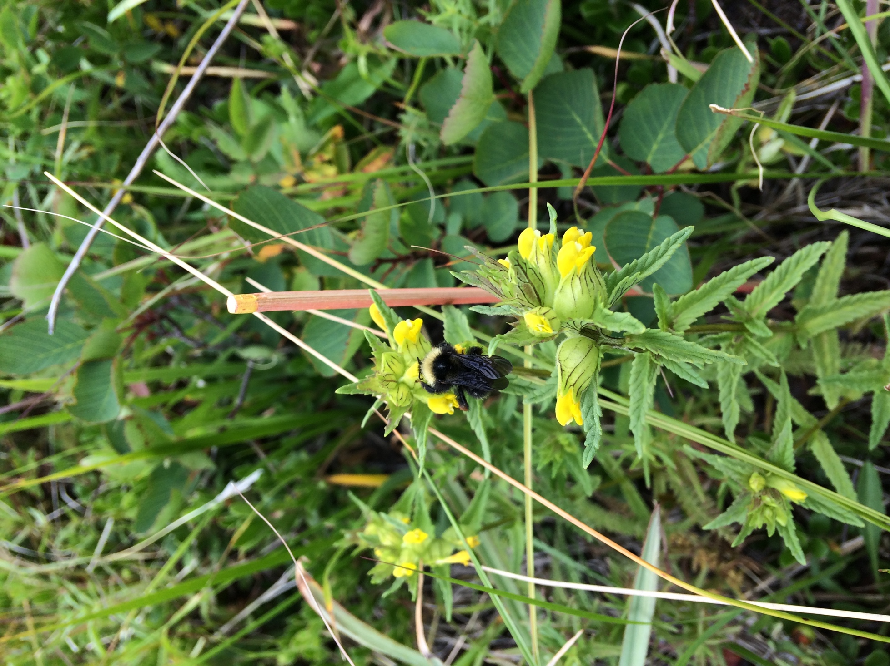

**Fig. 3.** Bumblebee (*Bombus* spp.) sippin’ on a *Rhinanthus minor* flower. The painted bamboo skewer is one of our natural plant markers indicating that this is a plant we tracked from emergence.